17th April 2013

**YOKOHAMA to Expand Truck/Bus Tyre Production Capacity in Thailand**

Tokyo - The YOKOHAMA Rubber Co., Ltd., announced today that it would start building a new plant for YOKOHAMA Tire Manufacturing (Thailand) Co., Ltd. (YTMT) as the Phase-II expansion of its truck/bus (TB) tyre production capacity in this July. YOKOHAMA plans to build the new plant on an already-acquired land adjacent to an existing TB tyre plant of the YTMT. YOKOHAMA invests a total of 8 billion yen to build the second plant with a building area of 2.6 hectares. With the expansion, YOKOHAMA will increase TB tyre production capacity of the subsidiary from 350,000 to 700,000 tyres a year. The second plant will start manufacturing operation in April 2015 and full-fledged operation in December of the same year.

Established in January 2004 in Rayong Province, Thailand, the YTMT started manufacturing TB tyres in April 2005. The YTMT is exporting the tyres mainly to the North American and European markets for replacement tyres. YOKOHAMA plans to increase sales of TB tyres globally and has therefore decided to expand the capacity of the YTMT to speedily follow the sales increase.

The YTMT is a general tyre manufacturer and has another plant for manufacturing passenger car and light truck (PC/LT) tyres on the same premises. The PC/LT tyre plant started operation in November 2006 at a production capacity of 1.4 million tyres a year. After performing Phase-III expansions, the annual production capacity of the plant now stands at 4 million tyres.

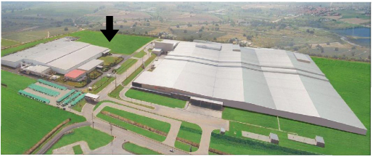

*External view of the YTMT.*

*The area indicated by an arrow is the land for constructing the second TB tyre plant.*

**■Outline of YOKOHAMA Tire Manufacturing (Thailand) Co., Ltd.**

Lines of business: Manufacture and sale of truck/bus, passenger car and light truck tyres

Site area: 41.8 hectares

Representative: Yasuhiro Mizumoto

No. of employees: 1,904 (as of the end of December 2012)

Location: Amata City Industrial Estate, Rayong Province, Thailand